Software Design Document

Reservation System Accommodation Management Library

Sherwin Price

SWEN 646 9040: Software Design and Implementation

Course: ITEC-646-9040

Date: 09/23/2025

Table of Contents
1 Introduction 4
1.1 Purpose 4
1.2 Scope 4
1.3 Overview 4
1.4 Reference Materials 5
1.5 Definitions Acronyms 6
2 System Overview 7
3 System Architecture 8
3.1 Architectural Design 8
3.2 Decomposition Description 8
3.3 Exception Handling 9
3.4 Design Rationale 9
4 Data Design 10
4.1 Data Description 10
4.2 Data Dictionary 10
5 Component Design 11
6 Human Interface Design 14
6.1 Overview of User Interface 14
6.2 Screen Images 14
6.3 Screen Objects and Actions 14
7 Requirements Matrix 14
8 APPENDICES 15
This section is optional. 15

Introduction

Purpose
This document describe the design and build of prototype software, as a stand-alone application, loaded on a business’s local computer to manage accounts and associated accommodation reservations. This document is intended for Project Managers, Software Engineers, and anyone else who will be involved in the implementation of the system.

Scope
This software will be used and called by User Interface (UI) that someone else will be implementing. The UI screens will be touched on in this software design document (SDD) but will not be implementing for this project.

Overview
Design uses the file-system for storage. System architecture will be based on separately coded modules as libraries, and follow Model-View-ViewModel pattern represented as:

A-Data-Repository store on the file-system with data modeled in JSON formatted files.
A single configured directory on host file-system contains all the account and reservation files.


Client App driver Code will implement the Query Layer and UI View Layer.

For test purposes this can be given as constant value in the API Manager class. Each managed account is saved in a separate directory named as the account’s number. The account information is saved in one file and then each reservation that belongs to that account in separate file. The account file has all the reservation numbers associated with the account. Reservation file data is similarly saved in a separate file, with the associated account number. Accounts and Reservations are stored by the manager class using the Java package library code and the data is stored on the file system.

Reference Materials

To validate that the data repository API works as intended, test code has been written and provided with the deployment to evaluate the deployed system. A single test class ‘TestReservations’ contains a main function that drives test functions. Each test case scenario executes as a separate method called by the main method. All methods should be able to run at once or select a single method to run by commenting out calls to the other methods. Comments in the source file document what each test case is verifying and doing. Each test case output a brief description of what is tested and then some output.

- Dea, C. (2023). cognitive. GitHub. https://github.com/carldea/cognitive

Definitions Acronyms

System Overview

The API Manager class in the LIB would be given a directory to configure as a repository for the application, data will be loaded and saved in the repository. The manager loads and updates storage for all the existing accounts and their associated reservations. For this project, the full path for the directory is hard-coded in the API Manager class. Each account’s data is saved on a file named as the account’s number. Account information is saved in one file and Reservation data is also saved in a single file. Each reservation that belongs to an account is reference in the account file. The file’s format uses a Line Delimited JSON format also known as json lines (JSONL).
An application user interface will be considered in this design document. The architecture to be considered for implementation is Model-View-ViewModel design pattern. In this design the Model would be our reservationsystem-java-coded package, hosted in Java SE runtime. The View can be coded using a multi-platform model using OpenJFX(Dea, C. 2023). The user will see and interact with the JavaFX loaded UI html views and JavaFX will handle event-handler call-back from specific view controller code. Using JavaFX allows all 3 separate module, Model, View, ViewModel to live in the same app runtime of Java SE. Secondly deployment packaging can use JDK jpackage to create install packages for major desktops platforms.
To support the user interface separation where the ViewModel data entity is presented on a client separate from storage at the data-store a Session-layer interface is introduced. This will contain application components services ( middle-tier ) where lively-ness of data-entities flowing between the UI-layer and the data-service in the Pager/Indexer in the Data-Storage component. Typically this would result in a Ntier application design, where both the Session-Layer and Pager-Layer would live in a server-side tier. Then any view-ViewModel would initialize with a connection. Some software components that support the connection would be Server-Sent-Events a browser facility available ECMAScript web browsers, where the web browser platform maintains the connection for the javascript runetime in the browser. An additional feature of Server-Sent-Events is the server can send events to the UI-Scripted library component out-of-band after secure-connection is made. All connections in the application user interface libraries are expected to be over TLS 1.3. In this project case modern Java versions (e.g., Java 24 with JEP 517) will be used with built-in support for HTTP/3, where UDP connections with the session-layer is already supported by the Java client process hosted in the Operating System.

System Architecture

Architectural Design
Provide a class diagram showing the major subsystems and data repositories and their interconnections (this is the diagram you have been working on for the past few weeks).

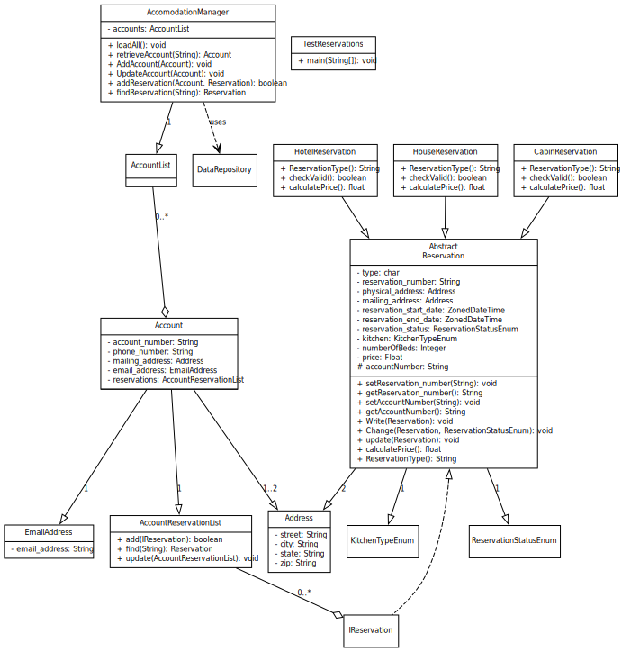

Decomposition Description
Provide a decomposition of the subsystems in the architectural design in section 3.1. Explain how the classes work together (relationships and dependencies) and the data flow through the system.

Exception Handling
System has application throws runtime exceptions IllegalOperationException when checkValid functions are called through Account and Reservation record load and update functions. In addition the record load can cause the DuplicateObjectException to be thrown. The error message set on the exception generation includes the causal data, such as account and check that failed. This information is displayed in the toString() output on the exception type.
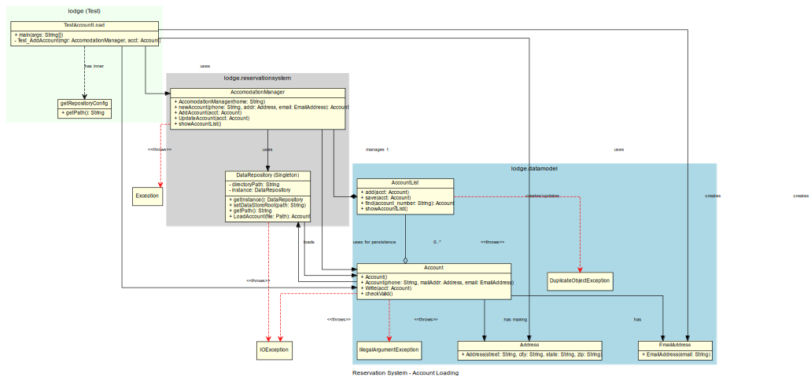

Design Rationale
Discuss the rationale for selecting the architecture described in 3.1 including critical issues and trade/offs that were considered. You may discuss other architectures that were considered, provided that you explain why you didn’t choose them.

Data Design

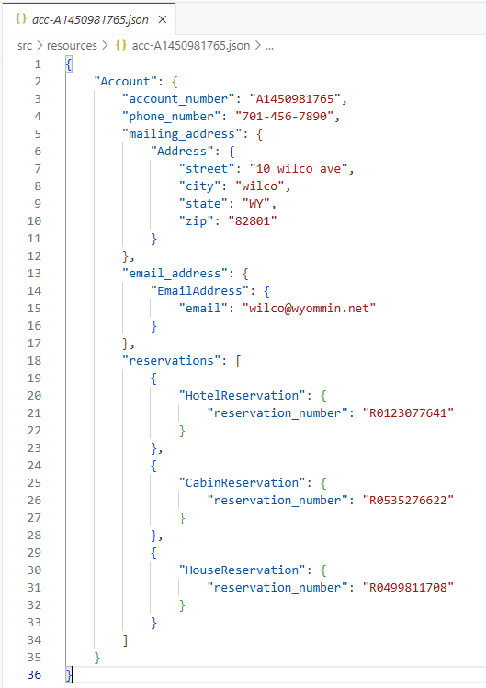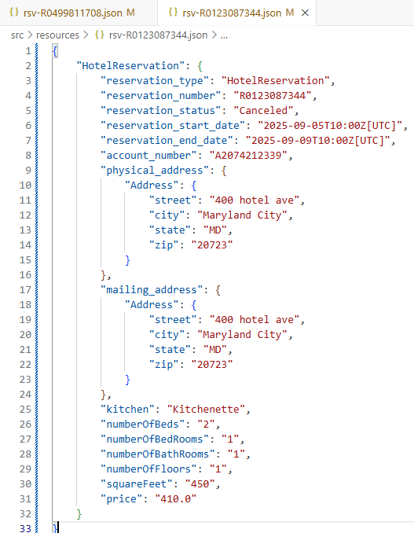

Data Description
Explain how the information domain of your system is transformed into data structures. Describe how the major data or system entities are stored, processed and organized. For your project that means describing the text file(s) that will be used for the storage of data to include naming convention and the exact format of the data in the file. Give specific example of the contents of the file(s).

Data Dictionary
Alphabetically list the system entities or major data along with their types and descriptions. For OO design list the objects and its attributes, methods and method parameters.

Component Design
In this section, we take a closer look at what each component does in a more systematic way. For OO description, summarize each object member function for all the objects listed in 3.2 in code or pseudocode. Describe any local data when necessary. Use the class template (Class Name, Class Description, Class Modifiers, Class Inheritance, Class Attributes, Exceptions Thrown, and Class Methods) for each class.

For each constructor and method you need code or pseudocode - the steps the constructor/method must make to complete the action it is supposed to do.

Class Name: lodge.reservationsystem.AccomodationManager
Class Description/Purpose: Manager fascade to library operations. Initialize the system.
Exceptions Thrown: DuplicateObjectException, IllegalOperationException, IOException
Class Constructors: AccomodationManager(String)
Class Methods:
loadAll:void
retrieveAccount(String):void
AddAccount(Account):void
addReservation(Account, Reservation):boolean
findReservation(String):Reservation

Class Name: lodge.reservationsystem.CabinReservation
Class Description/Purpose: Concrete reservation data class for reservation json storage record.
Exceptions Thrown: InvalidOperationException
Class Constructors: CabinReservation(Address)
Class Methods:
checkValid():boolean
calculatePrice():float
ReservationType():String

Class Name: lodge.reservationsystem.HotelReservation
Class Description/Purpose: Concrete reservation data class for reservation json storage record.
Exceptions Thrown: InvalidOperationException
Class Constructors: HotelReservation(Address)
Class Methods:
checkValid():boolean
calculatePrice():float
ReservationType():String

Class Name: lodge.reservationsystem.HouseReservation
Class Description/Purpose: Concrete reservation data class for reservation json storage record.
Exceptions Thrown: InvalidOperationException
Class Constructors: HouseReservation(Address)
Class Methods:
checkValid():boolean
calculatePrice():float
ReservationType():String

Class Name: lodge.data.Reservation
Class Description/Purpose: Abstract class for reservation json storage record.
Collects reservation common attributes,
and hash instances to enforce uniqueness.
Exceptions Thrown:
Class Constructors:
Class Methods:
Write(Reservation)
Change(Reservation, ReservationStatusEnum)
Update(Reservation)
CalculatePrice():float

Class Name: lodge.data.AccountReservationList
Class Description/Purpose: List of reservations held owned by each account.
Exceptions Thrown: InvalidOperationException
Class Constructors: AccountReservationList()
Class Methods:
add(Reservation):Boolean
find(String):Reservation
update(AccountReservationList):void

Class Name: lodge.data.Account
Class Description/Purpose: Concrete account data class for account json storage record.
Collects account attributes, and hash instances to enforce uniqueness.
Exceptions Thrown: InvalidOperationException
Class Constructors: Account(Address, String)
Class Methods:

Class Name: lodge.data.AccountList
Class Description/Purpose: Concrete account data class for account json storage record.
Exceptions Thrown: InvalidOperationException
Class Constructors: Account(String,String,Address,EmailAddress)
Class Methods:
static accountSerial(String,Address,EmailAddress):String
add(Account):Boolean
find(String):Account
save(Account):void
Java Package Organization: java source packages:
lodge: lodge.data,
lodge.data.reservation
lodge.reservationsystem
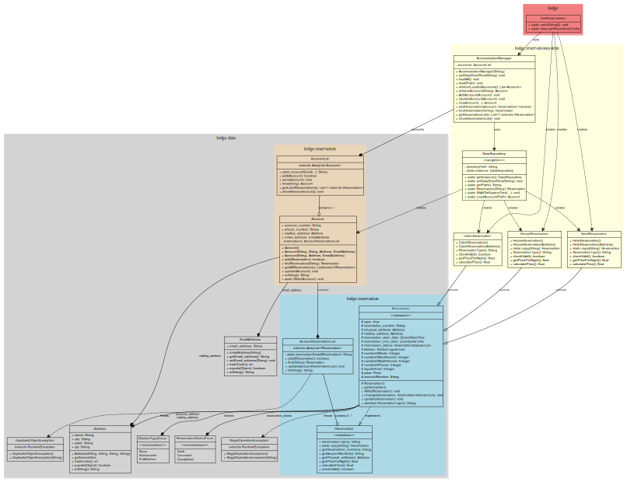
Test driver java class lodge.TestReservations, implements scripted tests against the packages. Class diagram of the java components this class tests: chart shows how accounts, reservations, and the accommodation management system data models are related.

HotelReservation, HouseReservation, and CabinReservation extend Reservation

Exception Classess in gray are thrown by AccountReservationList and AccountList DuplicateObjectException, IllegalOperationException)

Relationships:
Interface Implementation (dashed empty arrow): Reservation implements IReservation
Composition (filled diamond): Strong ownership like Account containing AccountReservationList
Aggregation (empty diamond): Weaker ownership like AccomodationManager managing AccountList
Dependencies (dashed arrow): relationships between classes

Design Patterns:
Singleton Pattern: DataRepository uses the singleton pattern
Factory Method: DataRepository.Reservation(type) creates different reservation types

Human Interface Design

Overview of User Interface

Screen Images
Display all the screenshots showing the interface from the user’s perspective. These can be hand drawn or you can use an automated drawing tool. Just make them as accurate as possible and they need to be complete - all screens that user would interact with need to be included. Make sure all major functionality is accounted for in the images.
(Graph paper works well.)
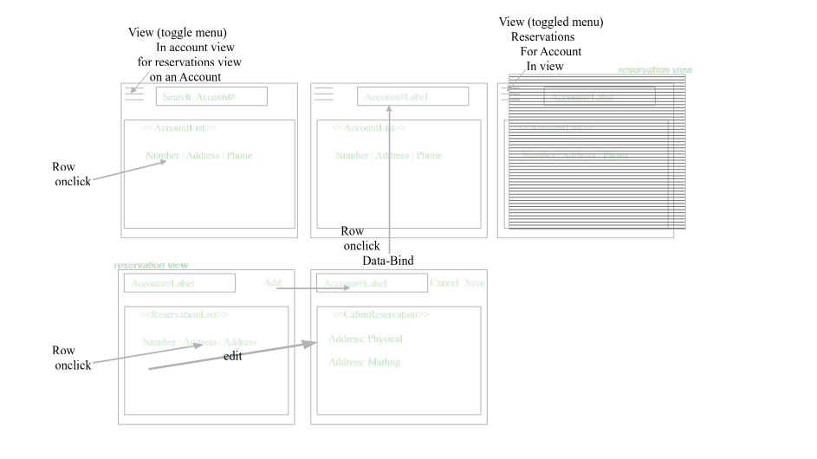

Screen Objects and Actions
A discussion of screen objects and actions associated with those objects.

Requirements Matrix
Provide a cross-reference that traces components and data structures to the requirements in your SRS document.

RQX-0001 | Project design is prototype software
RQX-0002 | Development of reservationsystem library will utilize Java Language (v24)
RQX-0003 | Intended for standalone application loaded on a business local computer
RQX-0004 | Prototype manage accounts and associated accomodation reservation
RQX-0005 | User Interface is implemented by another project
RQX-0006 | All existing accounts and associated reservations are loaded at startup.
RQX-0007 | Project hardcodes full path to a storage directory.
RQX-0008 | Account file name convention account start witn acc-#########.json
RQX-0009 | Reservation file name convention reservation start with rsv-##########.json
RQX-0011 | Manager is initialized on system startup with All Accounts loaded.
RQX-0012 | Account includes the following information:
RQX-0013 | unique generated number (A followed by 9 characters)
RQX-0014 | Account is created with list of reservations[empty]
RQX-0015 | with values in { account number mailing address phone number email address
RQX-0016 | Account number can not be changed.
RQX-0017 | Account can not be removed.
RQX-0018 | No duplicated accounts allowed.
RQX-0020 | Reservation is added to a specific account in draft status
RQX-0021 | Reservation can only be canceled if the start date is in the future
RQX-0022 | single test class with main
TSTQX-01 | Get the list of loaded accounts from Manager
TSTQX-02 | Retrieve a loaded account object that matches a specific account number
TSTQX-03 | Add new account object to the list managed by Manager (if account object already exists on add action with the same account number, it is considered an error)
TSTQX-04 | Request that Manager updates specific account�s files with data stored in memory
TSTQX-05 | Add draft lodging reservation to an account (if reservation object already exists with the same reservation number, it is considered an error)
TSTQX-06 | Complete reservation that is associated with an account
TSTQX-07 | Cancel reservation that is associated with an account
TSTQX-08 | Change reservation values that can be changed (if reservation is cancelled, completed, or for past date, it is considered an error)
TSTQX-09 | Request for price per night to be calculated and returned for a specific reservation
TSTQX-10 | Request for total reservation price to be calculated and returned for a specific reservation

APPENDICES

This section is optional.
Appendices may be included, either directly or by reference, to provide supporting details that could aid in the understanding of the Software Design Document.

Logged: Run
cd reservationsystem
java -XX:+ShowCodeDetailsInExceptionMessages -cp ./bin/main:./libs/gson-2.13.2.jar:./libs/error_prone_annotations-2.41.0.jar lodge.TestReservations

Logged: Test output on first run:
Directory: reservationsystem/src/resources
Deserializing LoadAll Accounts 0
Error No Dups, Reservation exists: R0535276622.
lodge.datamodel.IllegalOperationException: Invalid Change, reservation has begun.
Hotel Per Night Rate: 120.000000
Account A1450981765: R0535276622, 40 cabin ave
Account A1450981765: R0499811708, 3000 Osage ave
Account A2074212339: R0123087344, 400 hotel ave
Account A2074212339: R2042828431, 30 cabin ave
Program Completed.

Logged: Test output on second run:

Directory: reservationsystem/src/resources
File: reservationsystem/src/resources/acc-A1450981765.json
File: reservationsystem/src/resources/acc-A2074212339.json
File: reservationsystem/src/resources/res-R0123087344.json
File: reservationsystem/src/resources/res-R2042828431.json
File: reservationsystem/src/resources/res-R0535276622.json
File: reservationsystem/src/resources/res-R0499811708.json
Deserializing LoadAll Accounts 2
Account A1450981765 exists, duplicates not allowed.
Account A2074212339 exists, duplicates not allowed.
Error No Dups, Reservation exists: R0123087344.
Error No Dups, Reservation exists: R2042828431.
Error No Dups, Reservation exists: R0535276622.
Error No Dups, Reservation exists: R0499811708.
Error No Dups, Reservation exists: R0535276622.
lodge.datamodel.IllegalOperationException: Invalid Change, reservation has begun.
lodge.datamodel.IllegalOperationException: Invalid Change, reservation has Canceled.
lodge.datamodel.IllegalOperationException: Invalid Change, reservation has begun.
Hotel Per Night Rate: 120.000000
Account A1450981765: R0535276622, 40 cabin ave
Account A1450981765: R0499811708, 3000 Osage ave
Account A2074212339: R0123087344, 400 hotel ave
Account A2074212339: R2042828431, 30 cabin ave
Program Completed.

