Software Design Document

Reservation System Accommodation Management Library

Sherwin Price

SWEN 646 9040: Software Design and Implementation

Course: ITEC-646-9040

Date: 09/23/2025

Table of Contents
1 Introduction 4
1.1 Purpose 4
1.2 Scope 4
1.3 Overview 4
1.4 Reference Materials 5
1.5 Definitions Acronyms 6
2 System Overview 7
3 System Architecture 8
3.1 Architectural Design 8
3.2 Decomposition Description 8
3.3 Exception Handling 9
3.4 Design Rationale 9
4 Data Design 9
4.1 Data Description 9
4.2 Data Dictionary 10
5 Component Design 11
6 Human Interface Design 14
6.1 Overview of User Interface 14
6.2 Screen Images 14
6.3 Screen Objects and Actions 14
7 Requirements Matrix 14
8 APPENDICES 15
This section is optional. 15

Introduction

Purpose
This document describe the design and build of prototype software, as a stand-alone application, loaded on a business’s local computer to manage accounts and associated accommodation reservations. This document is intended for Project Managers, Software Engineers, and anyone else who will be involved in the implementation of the system.

Scope
This software will be used and called by User Interface (UI) that someone else will be implementing. The UI screens will be touched on in this software design document (SDD) but will not be implementing for this project.

Overview
Design uses the file-system for storage. System architecture will be based on separately coded modules as libraries, and follow Model-View-ViewModel pattern represented as:

Data-Repository stores program models as JSON on the file storage system.
A single configured directory on host file-system contains all the account and reservation files.


Client App driver Code will implement the Query Layer and UI View Layer.

For test purposes this can be given as constant value in the API Manager class. Each managed account is saved in a separate directory named as the account’s number. The account information is saved in one file and then each reservation that belongs to that account in separate file. The account file has all the reservation numbers associated with the account. Reservation file data is similarly saved in a separate file, with the associated account number. Accounts and Reservations are stored by the manager class using the Java package library code and the data is stored on the file system.

Reference Materials

To validate that the data repository API works as intended, test code has been written and provided with the deployment to evaluate the deployed system. A single test class ‘TestReservations’ contains a main function that drives test functions. Each test case scenario executes as a separate method called by the main method. All methods should be able to run at once or select a single method to run by commenting out calls to the other methods. Comments in the source file document what each test case is verifying and doing. Each test case output a brief description of what is tested and then some output.

- Dea, C. (2023). cognitive. GitHub. https://github.com/carldea/cognitive

Definitions Acronyms

System Overview

The API Manager class in the LIB would be given a directory to configure as a repository for the application, data will be loaded and saved in the repository. The manager loads all the existing accounts and their associated reservations on startup. For this project, the full path for the directory is hard-coded. Each account’s data should be saved in named as the account’s number. Account information is saved in one file. Reservation data is also saved in a single file. Each reservation that belongs to an account is reference in the account file.
An application user interface will be considered in this design document. The architecture to be considered for implementation is Model-View-ViewModel design pattern. In this design the Model would be our reservationsystem-java-coded package, hosted in Java SE runtime. The View can be coded using a multi-platform model using OpenJFX(Dea, C. 2023). The user will see and interact with the JavaFX loaded UI html views and JavaFX will handle event-handler call-back from specific view controller code. Using JavaFX allows all 3 separate module, Model, View, ViewModel to live in the same app runtime of Java SE. Secondly deployment packaging can use JDK jpackage to create install packages for major desktops platforms.

System Architecture

Architectural Design
Provide a class diagram showing the major subsystems and data repositories and their interconnections (this is the diagram you have been working on for the past few weeks).

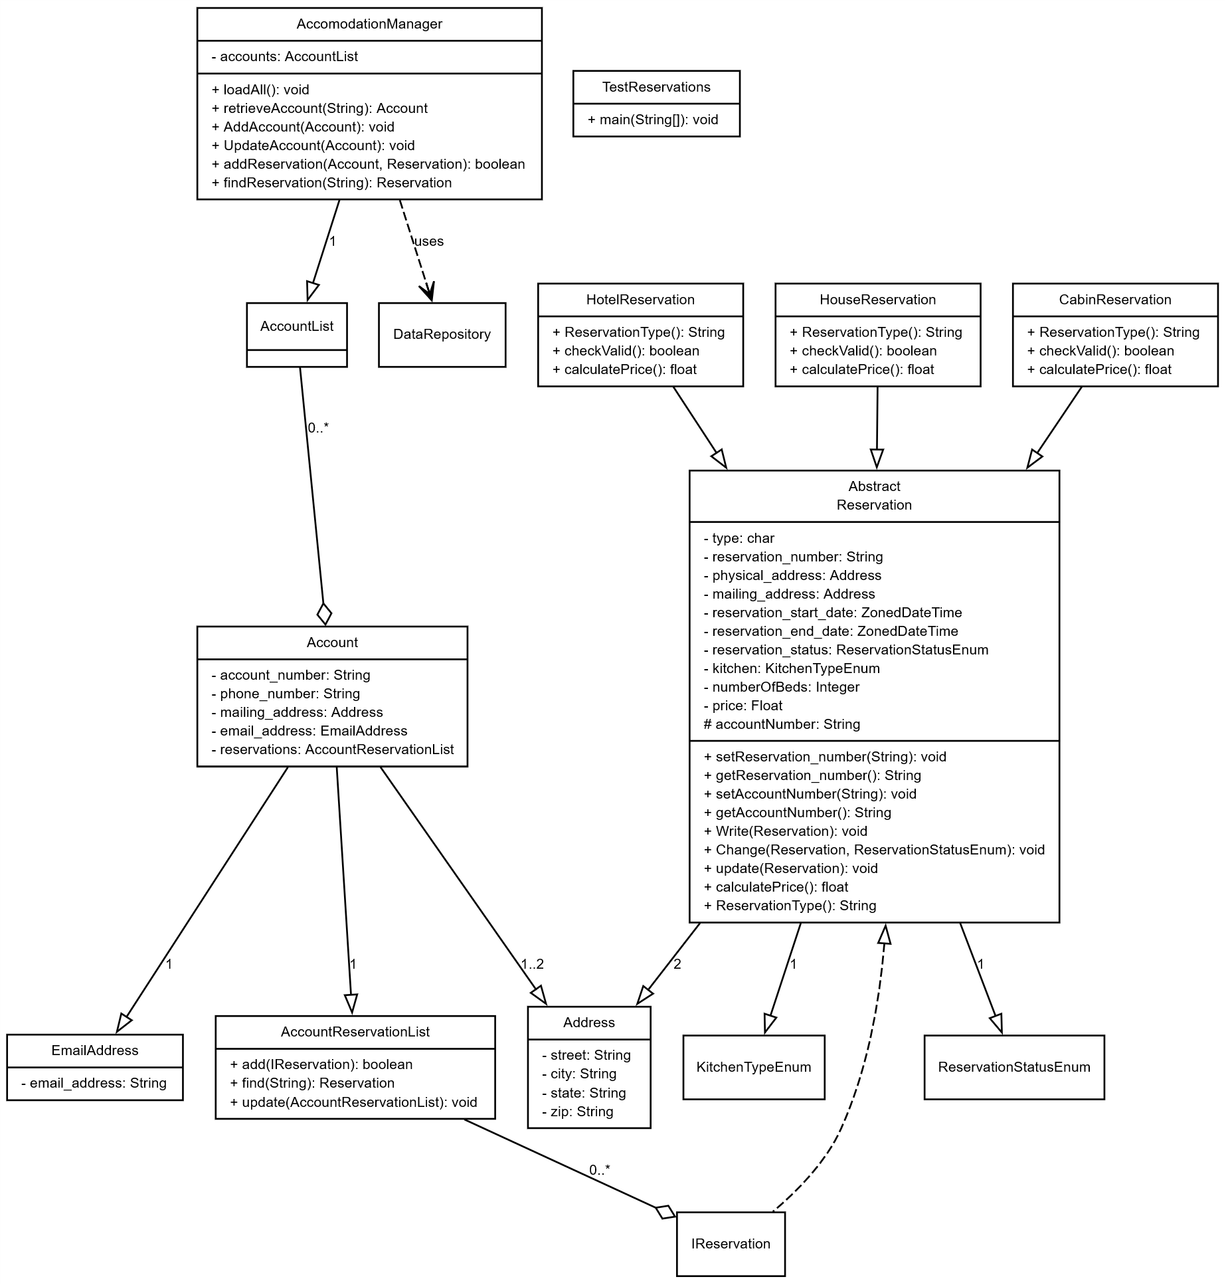

Decomposition Description
Provide a decomposition of the subsystems in the architectural design in section 3.1. Explain how the classes work together (relationships and dependencies) and the data flow through the system.

Exception Handling
Briefly summarize each user defined exception to include what data must be passed in the constructor(s), what message(s) will be generated, and which class and methods will throw the exceptions.

Design Rationale
Discuss the rationale for selecting the architecture described in 3.1 including critical issues and trade/offs that were considered. You may discuss other architectures that were considered, provided that you explain why you didn’t choose them.

Data Design

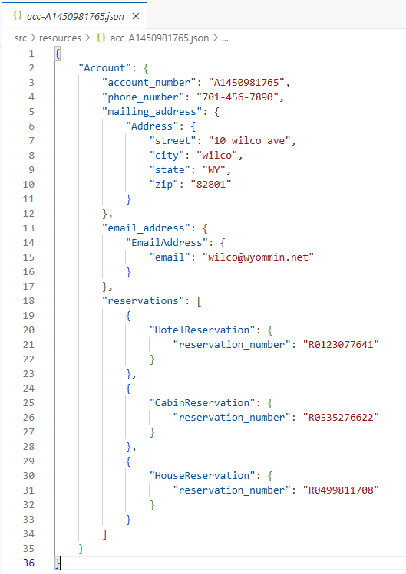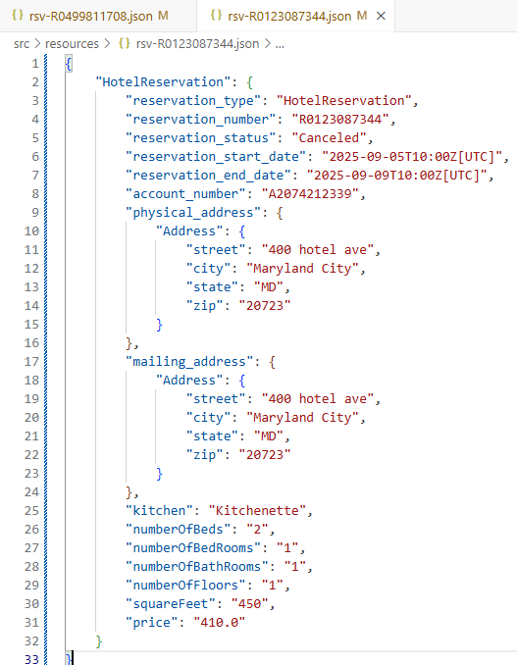

Data Description
Explain how the information domain of your system is transformed into data structures. Describe how the major data or system entities are stored, processed and organized. For your project that means describing the text file(s) that will be used for the storage of data to include naming convention and the exact format of the data in the file. Give specific example of the contents of the file(s).

Data Dictionary
Alphabetically list the system entities or major data along with their types and descriptions. For OO design list the objects and its attributes, methods and method parameters.

Component Design
In this section, we take a closer look at what each component does in a more systematic way. For OO description, summarize each object member function for all the objects listed in 3.2 in code or pseudocode. Describe any local data when necessary. Use the class template (Class Name, Class Description, Class Modifiers, Class Inheritance, Class Attributes, Exceptions Thrown, and Class Methods) for each class.

For each constructor and method you need code or pseudocode - the steps the constructor/method must make to complete the action it is supposed to do.

Class Name: lodge.reservationsystem.AccomodationManager
Class Description/Purpose: Manager fascade to library operations. Initialize the system.
Exceptions Thrown: DuplicateObjectException, IllegalOperationException, IOException
Class Constructors: AccomodationManager(String)
Class Methods:
loadAll:void
retrieveAccount(String):void
AddAccount(Account):void
addReservation(Account, Reservation):boolean
findReservation(String):Reservation

Class Name: lodge.reservationsystem.CabinReservation
Class Description/Purpose: Concrete reservation data class for reservation json storage record.
Exceptions Thrown: InvalidOperationException
Class Constructors: CabinReservation(Address)
Class Methods:
checkValid():boolean
calculatePrice():float
ReservationType():String

Class Name: lodge.reservationsystem.HotelReservation
Class Description/Purpose: Concrete reservation data class for reservation json storage record.
Exceptions Thrown: InvalidOperationException
Class Constructors: HotelReservation(Address)
Class Methods:
checkValid():boolean
calculatePrice():float
ReservationType():String

Class Name: lodge.reservationsystem.HouseReservation
Class Description/Purpose: Concrete reservation data class for reservation json storage record.
Exceptions Thrown: InvalidOperationException
Class Constructors: HouseReservation(Address)
Class Methods:
checkValid():boolean
calculatePrice():float
ReservationType():String

Class Name: lodge.data.Reservation
Class Description/Purpose: Abstract class for reservation json storage record.
Collects reservation common attributes,
and hash instances to enforce uniqueness.
Exceptions Thrown:
Class Constructors:
Class Methods:
Write(Reservation)
Change(Reservation, ReservationStatusEnum)
Update(Reservation)
CalculatePrice():float

Class Name: lodge.data.AccountReservationList
Class Description/Purpose: List of reservations held owned by each account.
Exceptions Thrown: InvalidOperationException
Class Constructors: AccountReservationList()
Class Methods:
add(Reservation):Boolean
find(String):Reservation
update(AccountReservationList):void

Class Name: lodge.data.Account
Class Description/Purpose: Concrete account data class for account json storage record.
Collects account attributes, and hash instances to enforce uniqueness.
Exceptions Thrown: InvalidOperationException
Class Constructors: Account(Address, String)
Class Methods:

Class Name: lodge.data.AccountList
Class Description/Purpose: Concrete account data class for account json storage record.
Exceptions Thrown: InvalidOperationException
Class Constructors: Account(String,String,Address,EmailAddress)
Class Methods:
static accountSerial(String,Address,EmailAddress):String
add(Account):Boolean
find(String):Account
save(Account):void
Java Package Organization: java source packages:
lodge: lodge.data,
lodge.data.reservation
lodge.reservationsystem
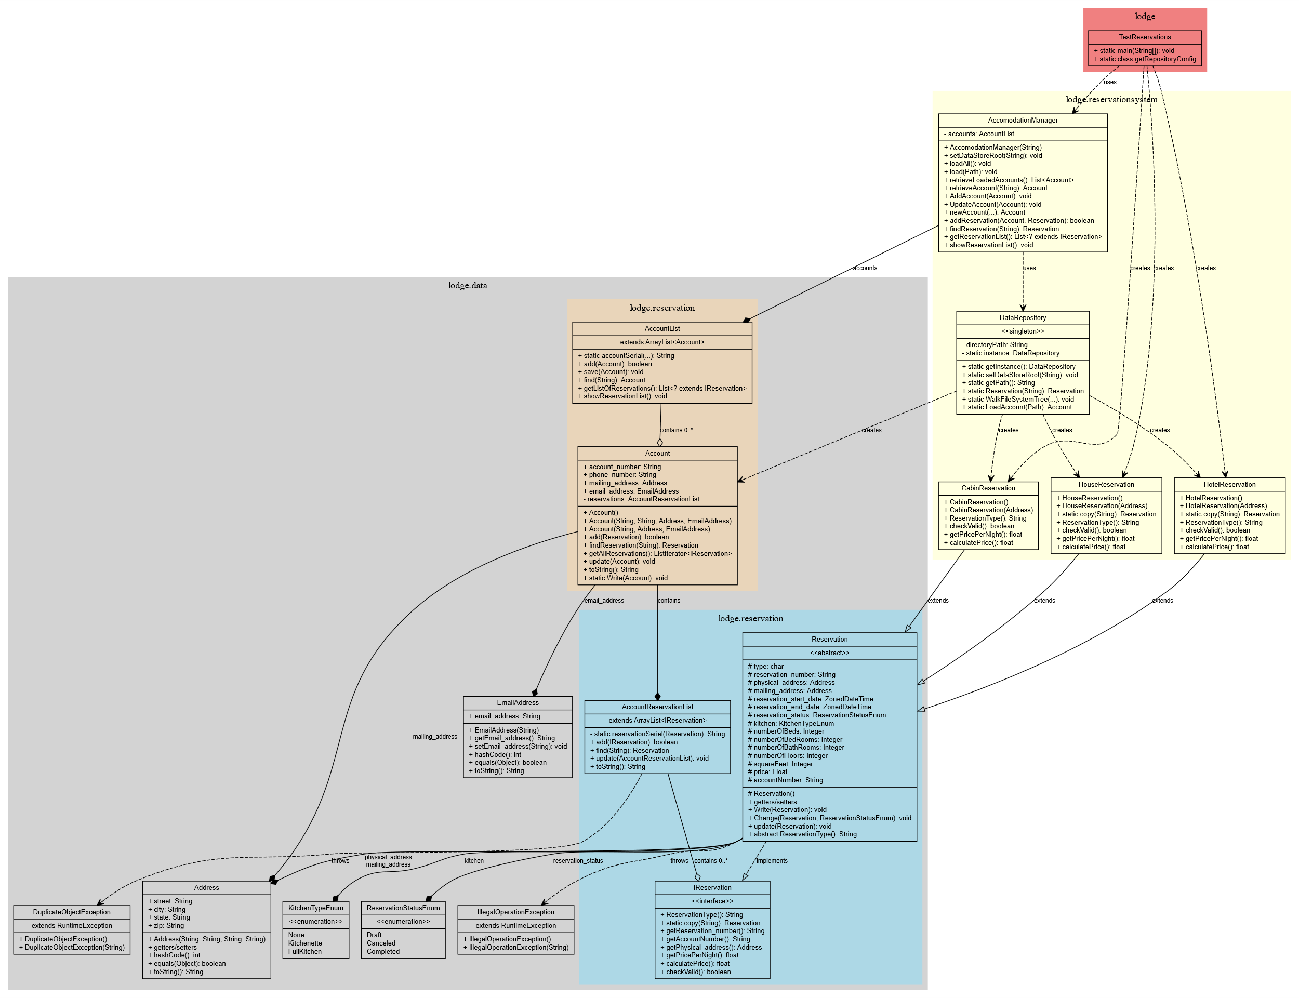
Test driver java class lodge.TestReservations, implements scripted tests against the packages. Class diagram of the java components this class tests: chart shows how accounts, reservations, and the accommodation management system data models are related.

HotelReservation, HouseReservation, and CabinReservation extend Reservation

Exception Classess in gray are thrown by AccountReservationList and AccountList DuplicateObjectException, IllegalOperationException)

Relationships:
Interface Implementation (dashed empty arrow): Reservation implements IReservation
Composition (filled diamond): Strong ownership like Account containing AccountReservationList
Aggregation (empty diamond): Weaker ownership like AccomodationManager managing AccountList
Dependencies (dashed arrow): relationships between classes

Design Patterns:
Singleton Pattern: DataRepository uses the singleton pattern
Factory Method: DataRepository.Reservation(type) creates different reservation types

Human Interface Design

Overview of User Interface

Screen Images
Display all the screenshots showing the interface from the user’s perspective. These can be hand drawn or you can use an automated drawing tool. Just make them as accurate as possible and they need to be complete - all screens that user would interact with need to be included. Make sure all major functionality is accounted for in the images.
(Graph paper works well.)

Screen Objects and Actions
A discussion of screen objects and actions associated with those objects.

Requirements Matrix
Provide a cross-reference that traces components and data structures to the requirements in your SRS document. Use a tabular format to show which system components satisfy each of the functional requirements from the SRS. For each requirement you need to specify the class, and/or attribute, and/or method that would satisfy that requirement.

APPENDICES

This section is optional.
Appendices may be included, either directly or by reference, to provide supporting details that could aid in the understanding of the Software Design Document.

Logged: Test output:
<<workspace>>/reservationsystem$ /usr/bin/env /usr/lib/jvm/java-21-openjdk-amd64/bin/java -jar lodge.TestReservations
Directory: <<workspace>>//reservationsystem/src/resources
File: <<workspace>>//reservationsystem/src/resources/acc-A1450981765.json
File: <<workspace>>//reservationsystem/src/resources/acc-A2074212339.json
File: <<workspace>>//reservationsystem/src/resources/rsv-R0123077641.json
File: <<workspace>>//reservationsystem/src/resources/rsv-R0499811708.json
File: <<workspace>>//reservationsystem/src/resources/rsv-R0535276622.json
File: <<workspace>>//reservationsystem/src/resources/rsv-R2042828431.json
Deserializing LoadAll Accounts 2
Error No Dups, Reservation exists: R0535276622.
lodge.data.IllegalOperationException: Invalid Change, reservation has Canceled.
lodge.data.IllegalOperationException: Invalid Change, reservation has begun.
Account A1450981765: R0123077641, 400 hotel ave
Account A1450981765: R0535276622, 40 cabin ave
Account A1450981765: R0499811708, 3000 Osage ave
Account A2074212339: R2042828431, 30 cabin ave
Program Completed.

