Software Design Document

Reservation System Accommodation Management Library

Sherwin Price

SWEN 646 9040: Software Design and Implementation

Course: ITEC-646-9040

Date: 09/23/2025

Table of Contents
1 Introduction 4
1.1 Purpose 4
1.2 Scope 4
1.3 Overview 4
1.4 Reference Materials 5
1.5 Definitions Acronyms 5
2 System Overview 6
3 System Architecture 7
3.1 Architectural Design 7
3.2 Decomposition Description 7
3.3 Exception Handling 9
3.4 Design Rationale 9
4 Data Design 10
4.1 Data Description 10
4.2 Data Dictionary 10
5 Component Design 10
6 Human Interface Design 10
6.1 Overview of User Interface 10
6.2 Screen Images 10
6.3 Screen Objects and Actions 10
7 Requirements Matrix 11
8 APPENDICES 12

Introduction

Purpose
This document describe the design and build of prototype software, as a stand-alone application, loaded on a business’s local computer to manage accounts and associated accommodation reservations. This document is intended for Project Managers, Software Engineers, and anyone else who will be involved in the implementation of the system.

Scope
This software will be used and called by User Interface (UI) that someone else will be implementing. The UI screens will be touched on in this software design document (SDD) but will not be implementing for this project.

Overview
Design uses the file-system for storage.
System architecture can be represented as:

Data-Repository ( stores program models as JSON on file-system )
Configured-Directory[on a local host system]
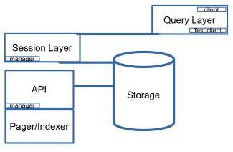

APP Driver Code will implement the Query Layer and UI View Layer.

For test purposes this can be given as a constant value in the API Manager class. Each managed account is saved in a separate directory named as the account’s number. The account information is saved in one file and then each reservation that belongs to that account in separate file. The account file has all the reservation numbers associated with the account. Reservation file data is similarly saved in a separate file, with the associated account number. Accounts and Reservations are stored by the manager class using the api library, and the stored data is on the file-system.

Reference Materials

To validate that the data repository API works as intended, test code has been written and provided with the deployment to evaluate the deployed system. A single test class ‘TestReservations’ contains a main functions that drives test functions. Each test case scenario executes as a separate method called by the main method. All methods should be able to run at once or select a single method to run by commenting out calls to the other methods. Comments in the source file document what each test case is verifying and doing. Each test case output a brief description of what is tested and then some output.

- OpenJS Foundation. (2025). Electron: Build cross-platform desktop apps with JavaScript, HTML, and CSS. Electron. https://www.electronjs.org/
- Jain, V. (2024, July 6). Introduction to Light-4J. Baeldung. https://www.baeldung.com/light-4j
- Microsoft. (2025, February 4). What is .NET MAUI? Microsoft Learn. Retrieved September 23, 2025, from https://learn.microsoft.com/en-us/dotnet/maui/what-is-maui?view=net-maui-9.0

Definitions Acronyms

System Overview

The API Manager class in the LIB would be given a directory configure a top level directory where the data for the application will be loaded and saved.
The manager class loads all the existing accounts and their associated reservations on startup. For this project, the full path for the directory is hard-coded. Each account’s data should be saved in named as the account’s number. Account’s information should be saved in one file and then each reservation that belongs to that account in separate file. The account file has all the reservation numbers associated with the account, but no other reservation data.
A UI application layer will be considered in this design document using a model-view-view-model design pattern. In this design the Model would be our reservationsystem-java-coded package, hosted in Java SE on Light-4j. The View can be coded in a Multi-platform App runtime using React Framework. This would be hosted in Electron (OpenJS Foundation. 2025) or Microsoft Blazor, .NET MAUI SDK. These platform runtimes can package to major desktops. The ViewModel is a middle-tier component, hosted with the React Application Acts as an intermediary between the Model and the View. Transforms data from the Model into a format suitable for display in the client Views. Manages presentation logic and handles user interactions, translating them into action commands on the Model.

System Architecture

Architectural Design

Decomposition Description

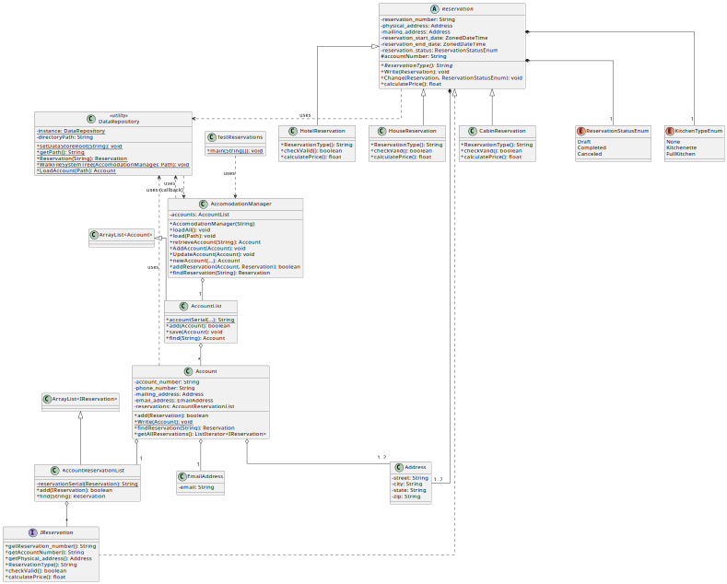

Exception Handling
Briefly summarize each user defined exception to include what data must be passed in the constructor(s), what message(s) will be generated, and which class and methods will throw the exceptions.

Design Rationale
Discuss the rationale for selecting the architecture described in 3.1 including critical issues and trade/offs that were considered. You may discuss other architectures that were considered, provided that you explain why you didn’t choose them.

Data Design
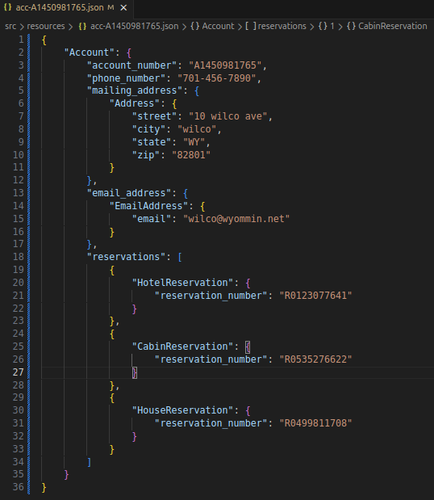

Data Description

Data Dictionary

Component Design

Java Package Organization: Java source code package classes are organized in
java packages:
lodge: lodge.data,
lodge.data.account
lodge.data.reservation
lodge.reservationsystem
Test driver class TestReservations.java, implements scripted tests against the packages. This class diagram depict a function overview of the java coded package, showing how accounts, reservations, and the accommodation management system data models are related.
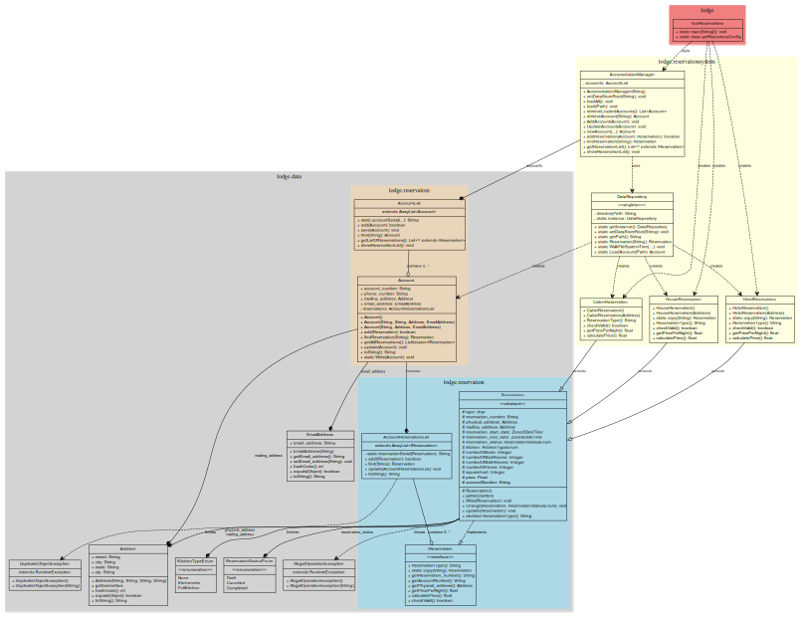

Class Types:
Regular classes (yellow boxes)
Abstract classes (gray - Reservation)
Interfaces (coral - IReservation)
Enumerations (gray - KitchenTypeEnum, ReservationStatusEnum)
Exceptions (gray - DuplicateObjectException, IllegalOperationException)

Relationships:
Inheritance (empty arrow): Shows class extensions like HotelReservation, HouseReservation, and CabinReservation extending Reservation
Interface Implementation (dashed empty arrow): Reservation implements IReservation
Composite structure are shown
Composition (filled diamond): Strong ownership like Account containing AccountReservationList
Aggregation (empty diamond): Weaker ownership like AccomodationManager managing AccountList
Dependencies (dashed arrow): relationships between classes
Design Patterns:
Singleton Pattern: DataRepository uses the singleton pattern
Factory Method: DataRepository.Reservation(type) creates different reservation types

Human Interface Design

Overview of User Interface

Screen Images

Screen Objects and Actions

Requirements Matrix

APPENDICES

Logged: Test output:
<<workspace>>/reservationsystem$ /usr/bin/env /usr/lib/jvm/java-21-openjdk-amd64/bin/java -jar lodge.TestReservations
Directory: <<workspace>>//reservationsystem/src/resources
File: <<workspace>>//reservationsystem/src/resources/acc-A1450981765.json
File: <<workspace>>//reservationsystem/src/resources/acc-A2074212339.json
File: <<workspace>>//reservationsystem/src/resources/rsv-R0123077641.json
File: <<workspace>>//reservationsystem/src/resources/rsv-R0499811708.json
File: <<workspace>>//reservationsystem/src/resources/rsv-R0535276622.json
File: <<workspace>>//reservationsystem/src/resources/rsv-R2042828431.json
Deserializing LoadAll Accounts 2
Error No Dups, Reservation exists: R0535276622.
lodge.data.IllegalOperationException: Invalid Change, reservation has Canceled.
lodge.data.IllegalOperationException: Invalid Change, reservation has begun.
Account A1450981765: R0123077641, 400 hotel ave
Account A1450981765: R0535276622, 40 cabin ave
Account A1450981765: R0499811708, 3000 Osage ave
Account A2074212339: R2042828431, 30 cabin ave
Program Completed.

