- Package Organization: Classes are organized from
java packages:
lodge: with mainClass in TestReservations.java
lodge.data,
lodge.reservation
lodge.reservationsystem
The diagram provides a complete overview of the system's architecture, showing how accounts, reservations, and the accommodation management system interact.

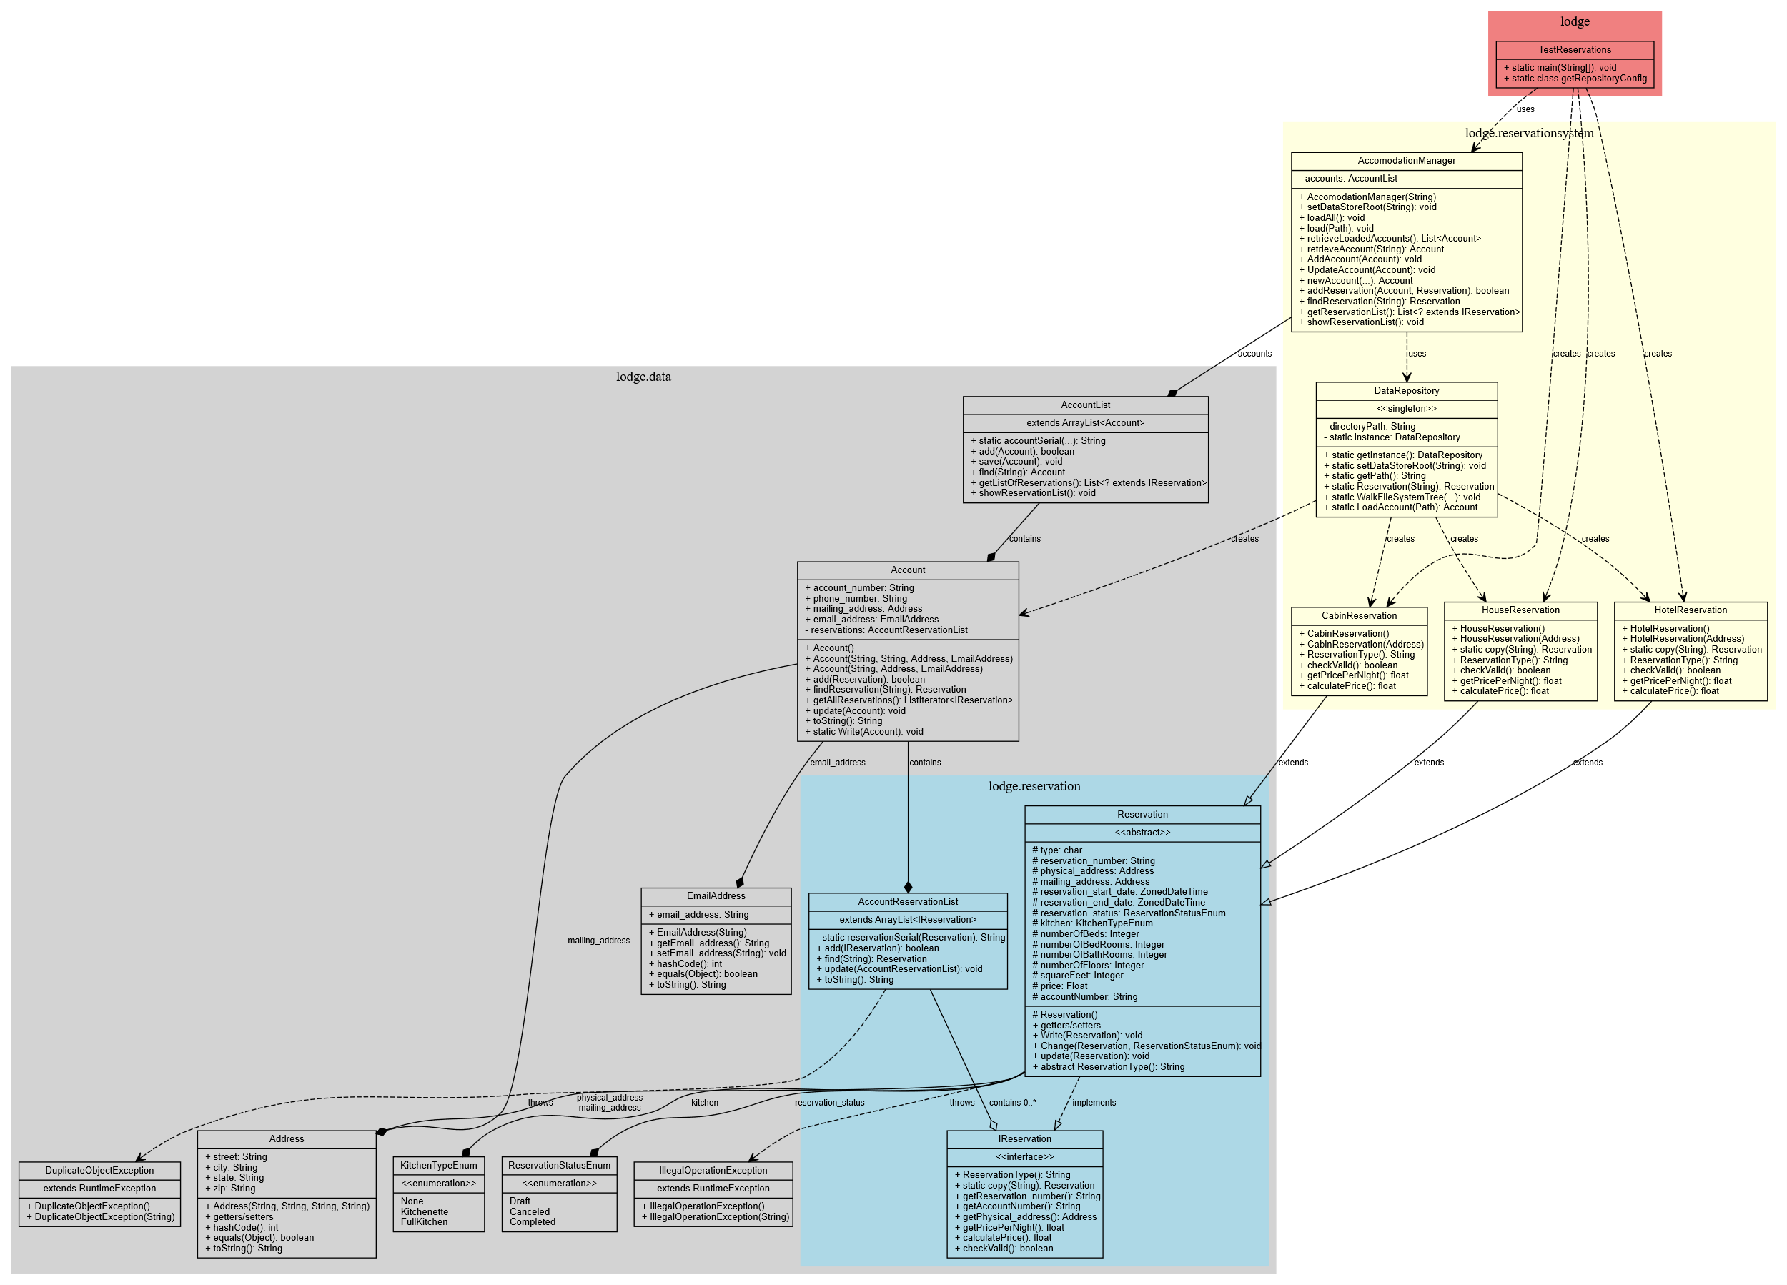

- Class Types:
  - Regular classes (yellow boxes)
  - Abstract classes (gray - Reservation)
  - Interfaces (green - IReservation)
  - Enumerations (blue - KitchenTypeEnum, ReservationStatusEnum)
  - Exceptions (coral - DuplicateObjectException, IllegalOperationException)

- Relationships:
  - Inheritance (empty arrow): Shows class extensions like HotelReservation, HouseReservation, and CabinReservation extending Reservation
  - Interface Implementation (dashed empty arrow): Reservation implements IReservation
  - Composition (filled diamond): Strong ownership like Account containing AccountReservationList
  - Aggregation (empty diamond): Weaker ownership like AccomodationManager managing AccountList
  - Dependencies (dashed arrow): Usage relationships between classes
- Design Patterns:
  - Singleton Pattern: DataRepository uses the singleton pattern
  - Factory Method: DataRepository.Reservation(type) creates different reservation types

