Software Design Document

Reservation System Accommodation Management Library

Sherwin Price

SWEN 646 9040: Software Design and Implementation

Course: ITEC-646-9040

Date: 09/23/2025

Table of Contents
1 Introduction 4
1.1 Purpose 4
1.2 Scope 4
1.3 Overview 4
1.4 Reference Materials 5
1.5 Definitions Acronyms 6
2 System Overview 7
3 System Architecture 8
3.1 Architectural Design 8
3.2 Decomposition Description 8
3.3 Exception Handling 8
3.4 Design Rationale 8
4 Data Design 9
4.1 Data Description 9
4.2 Data Dictionary 9
5 Component Design 10
6 Human Interface Design 12
6.1 Overview of User Interface 12
6.2 Screen Images 12
6.3 Screen Objects and Actions 12
7 Requirements Matrix 13
8 APPENDICES 14

Introduction

Purpose
This document describe the design and build of prototype software, as a stand-alone application, loaded on a business’s local computer to manage accounts and associated accommodation reservations. This document is intended for Project Managers, Software Engineers, and anyone else who will be involved in the implementation of the system.

Scope
This software will be used and called by User Interface (UI) that someone else will be implementing. The UI screens will be touched on in this software design document (SDD) but will not be implementing for this project.

Overview
Design uses the file-system for storage. System architecture will be based on separately coded modules as libraries, and follow Model-View-ViewModel pattern represented as:

Data-Repository ( stores program models as JSON on file-system )
Configured-Directory[on host file-system]


Client App driver Code will implement the Query Layer and UI View Layer.

For test purposes this can be given as constant value in the API Manager class. Each managed account is saved in a separate directory named as the account’s number. The account information is saved in one file and then each reservation that belongs to that account in separate file. The account file has all the reservation numbers associated with the account. Reservation file data is similarly saved in a separate file, with the associated account number. Accounts and Reservations are stored by the manager class using the api library, and the stored data is on the file-system.

Reference Materials

To validate that the data repository API works as intended, test code has been written and provided with the deployment to evaluate the deployed system. A single test class ‘TestReservations’ contains a main functions that drives test functions. Each test case scenario executes as a separate method called by the main method. All methods should be able to run at once or select a single method to run by commenting out calls to the other methods. Comments in the source file document what each test case is verifying and doing. Each test case output a brief description of what is tested and then some output.

- Dea, C. (2023). cognitive. GitHub. https://github.com/carldea/cognitive

Definitions Acronyms

System Overview

The API Manager class in the LIB would be given a directory to configure as a repository for the application, data will be loaded and saved in the repository. The manager loads all the existing accounts and their associated reservations on startup. For this project, the full path for the directory is hard-coded. Each account’s data should be saved in named as the account’s number. Account information is saved in one file similar to a reservation. Each reservation that belongs to an account is reference in the account file.
An application user interface will be considered in this design document. The architecture considered for implementation would be a Model-View-ViewModel design pattern. In this design the Model would be our reservationsystem-java-coded package, hosted in Java SE hosted in Java. The View can be coded using a multi-platform model using OpenJFX(Dea, C. 2023). The user will see and interact with the JavaFX loaded UI html views, and JavaFX will handle event-handlers call-back to the specific View Controller Java code. Using JavaFX allows all 3 separate module, Model, View, ViewModel to live in the same app runtime of Java SE. Secondly deployment packages in the JDK jpackage can package to major desktops installers.

System Architecture

Architectural Design

Decomposition Description

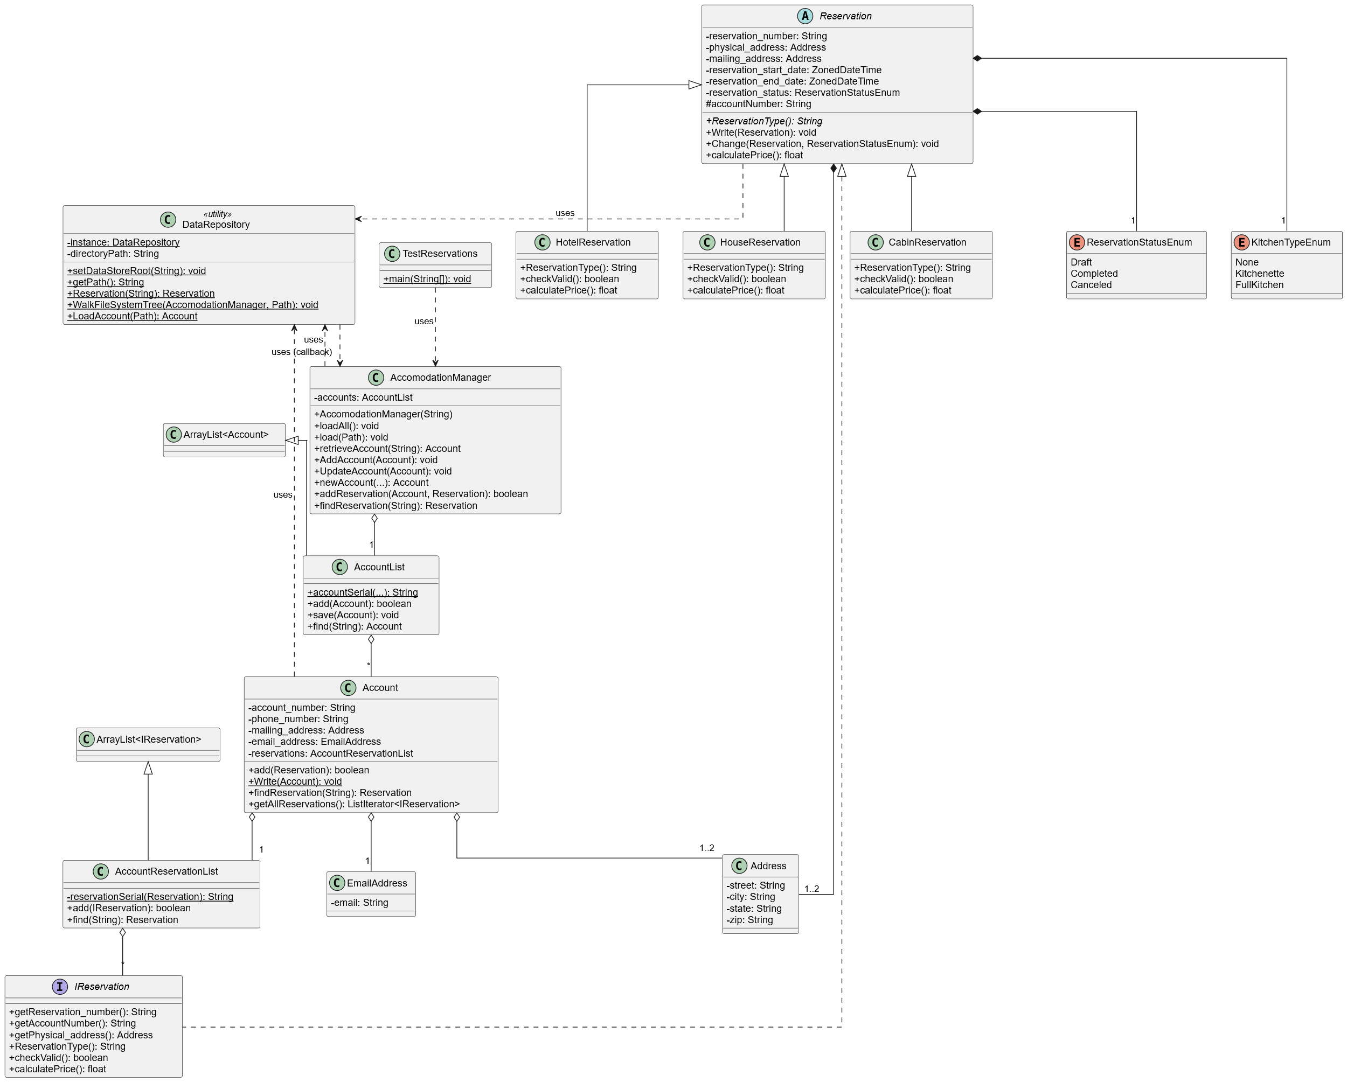

Exception Handling
Briefly summarize each user defined exception to include what data must be passed in the constructor(s), what message(s) will be generated, and which class and methods will throw the exceptions.

Design Rationale
Discuss the rationale for selecting the architecture described in 3.1 including critical issues and trade/offs that were considered. You may discuss other architectures that were considered, provided that you explain why you didn’t choose them.

Data Design
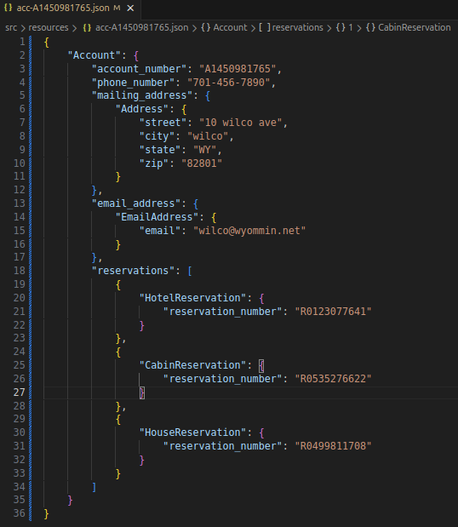

Data Description

Data Dictionary

Component Design

Java Package Organization: Java source code package classes are organized in
java packages:
lodge: lodge.data,
lodge.data.account
lodge.data.reservation
lodge.reservationsystem
Test driver class TestReservations.java, implements scripted tests against the packages. This class diagram depict a function overview of the java coded package, showing how accounts, reservations, and the accommodation management system data models are related.
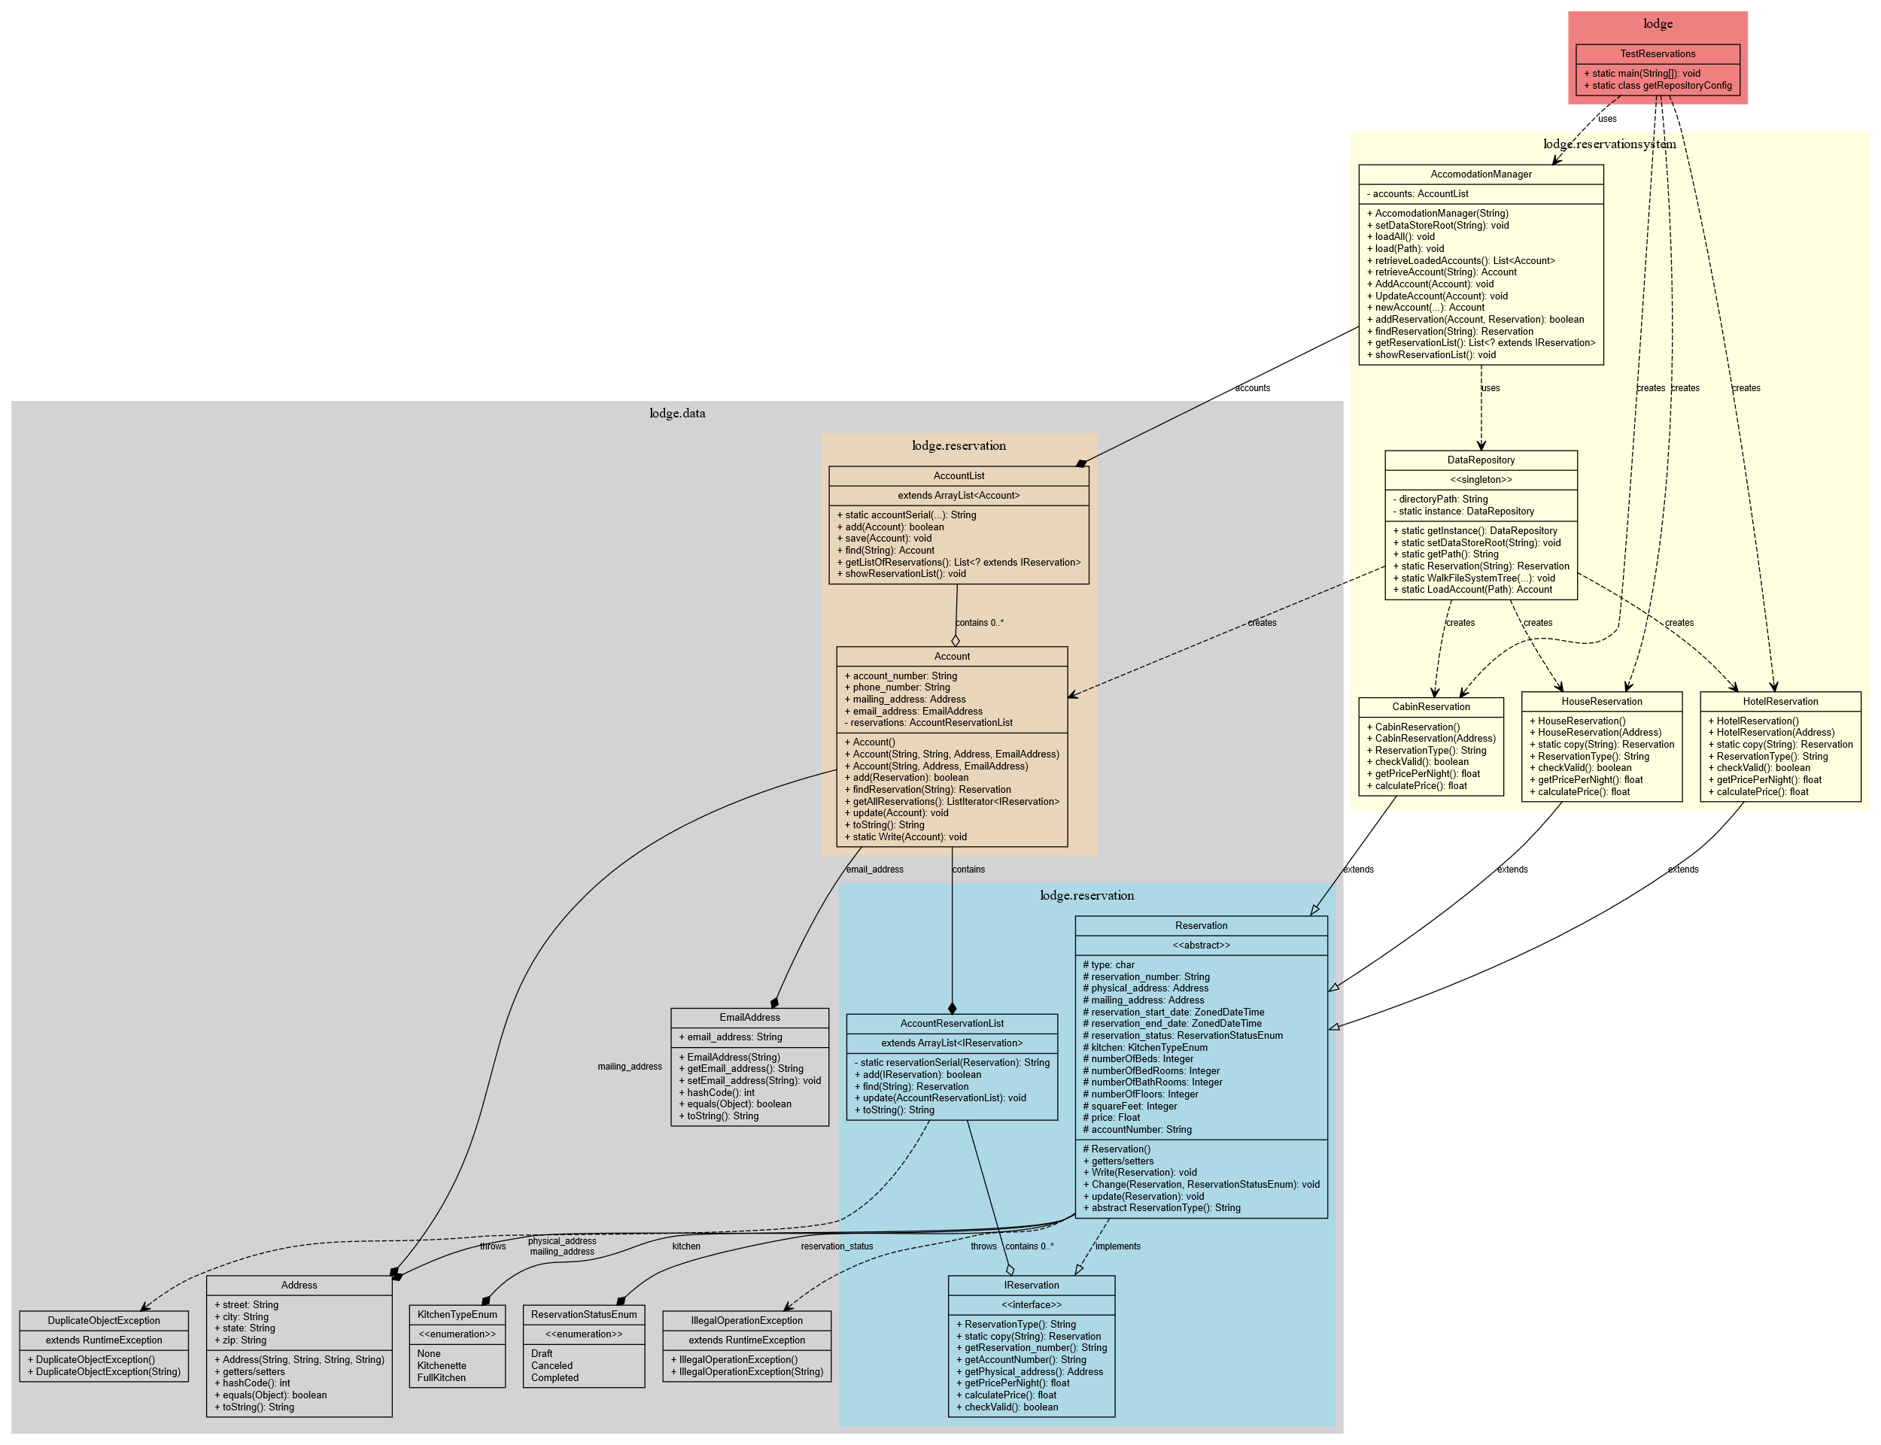

Class Types:
Regular classes (yellow boxes)
Abstract classes (gray - Reservation)
Interfaces (coral - IReservation)
Enumerations (gray - KitchenTypeEnum, ReservationStatusEnum)
Exceptions (gray - DuplicateObjectException, IllegalOperationException)

Relationships:
Inheritance (empty arrow): Shows class extensions like HotelReservation, HouseReservation, and CabinReservation extending Reservation
Interface Implementation (dashed empty arrow): Reservation implements IReservation
Composite structure are shown using:
Composition (filled diamond): Strong ownership like Account containing AccountReservationList
Aggregation (empty diamond): Weaker ownership like AccomodationManager managing AccountList
Dependencies (dashed arrow): relationships between classes
Design Patterns:
Singleton Pattern: DataRepository uses the singleton pattern
Factory Method: DataRepository.Reservation(type) creates different reservation types

Human Interface Design

Overview of User Interface

Screen Images

Screen Objects and Actions

Requirements Matrix

APPENDICES

Logged: Test output:
<<workspace>>/reservationsystem$ /usr/bin/env /usr/lib/jvm/java-21-openjdk-amd64/bin/java -jar lodge.TestReservations
Directory: <<workspace>>//reservationsystem/src/resources
File: <<workspace>>//reservationsystem/src/resources/acc-A1450981765.json
File: <<workspace>>//reservationsystem/src/resources/acc-A2074212339.json
File: <<workspace>>//reservationsystem/src/resources/rsv-R0123077641.json
File: <<workspace>>//reservationsystem/src/resources/rsv-R0499811708.json
File: <<workspace>>//reservationsystem/src/resources/rsv-R0535276622.json
File: <<workspace>>//reservationsystem/src/resources/rsv-R2042828431.json
Deserializing LoadAll Accounts 2
Error No Dups, Reservation exists: R0535276622.
lodge.data.IllegalOperationException: Invalid Change, reservation has Canceled.
lodge.data.IllegalOperationException: Invalid Change, reservation has begun.
Account A1450981765: R0123077641, 400 hotel ave
Account A1450981765: R0535276622, 40 cabin ave
Account A1450981765: R0499811708, 3000 Osage ave
Account A2074212339: R2042828431, 30 cabin ave
Program Completed.

